DATA ANALYTICS WITH POWER BI PROJECT REPORT
(Project Semester August-December 2025)

Real Weather Analytics Dashboard
Submitted by Anand Kumar
Registration No =12320597

Programme and Section - K23MG Course Code – INT 374

Under the Guidance of

Geetika Chatley UID = 25107

Discipline of CSE/IT

Lovely School of Computer Science and Engineering Lovely Professional University, Phagwara


CERTIFICATE

This is to certify that Anand Kumar bearing Registration no. 12320597 has completed INT 374 Course code project titled, “Real Weather Analytics Dashboard” under my guidance and supervision. To the best of my knowledge, the present work is the result of his/her original development, effort and study.

Signature and Name of the Supervisor Designation of the Supervisor

School of Computer Science and Engineering

Lovely Professional University Phagwara, Punjab.

Date: 20/12/2025

DECLARATION

I, Anand Kumar, student of B.Tech-CSE under CSE/IT Discipline at, Lovely Professional University, Punjab, hereby declare that all the information furnished in this project report is based on my own intensive work and is genuine.

Date: 20/12/2025 Signature: Anand Kumar

Registration No.: 12320597 Name of the student: Anand Kumar

Project Resources & Links

- Google Drive project folder link: https://drive.google.com/file/d/1loejnlgIycp4daC6-NcuSU83-aNSM2Sq/view?usp=drive_link

- LinkedIn profile link: https://www.linkedin.com/feed/update/urn:li:activity:7406832792334110720/
- Dataset link: Weatherapi.com

Table of Contents
- Introduction 6
- Source of Dataset 6
- Dataset Preprocessing 7
  - Temperature Measures 8
  - Time Intelligence (Current vs. Previous) 8
  - Categorical Logic (Grouping) 9
  - Dynamic Formatting (Coloring) 9
  - Advanced KPI: Rainfall Probability 9
- Analysis on Dataset 10
  - Objective 1: Temperature & Comfort Analysis 10
  - Objective 2: Precipitation & Humidity Trends 10
- Conclusion 11
- Future Scope 11
- References 12

Introduction
In the modern digital era, organizations generate a massive volume of data through daily business operations such as sales transactions, customer interactions, logistics, and employee activities. However, raw data by itself does not provide value unless it is properly processed, analyzed, and visualized. To address this challenge, Business Intelligence (BI) tools are widely used to convert raw data into meaningful information that supports strategic and operational decision-making.
Weather data analysis plays a vital role in understanding climatic patterns, predicting environmental changes, and supporting decision-making in sectors such as agriculture, travel, energy management, and disaster preparedness. With the rapid growth of data- driven technologies, tools like Power BI enable effective visualization and analysis of large-scale weather datasets.
This project focuses on analyzing real-time and historical weather data collected from WeatherAPI.com. The dataset includes key meteorological parameters such as temperature, humidity, wind speed, precipitation, atmospheric pressure, and weather conditions. The primary objective of this project is to explore weather trends, identify patterns, and present meaningful insights through interactive dashboards using Power BI.

Source of Dataset

The dataset used in this project is obtained from Weatherapi.com, a reliable online platform that provides real-time, historical, and forecast weather data through RESTful APIs.

Dataset Source Details:

- Website: WeatherAPI.com
- Data Type: Real-time and historical weather data
- Format: JSON (converted to tabular format for Power BI)
- Parameters Included:

- Date and time
- Location (city/region)
- Temperature (°C)
- Humidity (%)
- Wind speed (km/h)
- Precipitation (mm)
- Atmospheric pressure (mb)
- Weather condition (sunny, cloudy, rainy, etc.)

The dataset is considered authentic and accurate, making it suitable for analytical and visualization-based projects.

Dataset Preprocessing

Before analysis, the raw data obtained from WeatherAPI.com was preprocessed to ensure data quality and consistency.

Preprocessing Steps:

- Extracted JSON data using WeatherAPI endpoint
- Converted raw data into a structured table format
- Removed duplicate records
- Handled missing or null values
- Converted date and time into a proper datetime format
- Renamed columns for better readability
- Standardized measurement units (°C, km/h, mm)
- Filtered data based on required time period and location

These preprocessing steps improved data accuracy and made it suitable for analysis in Power BI.

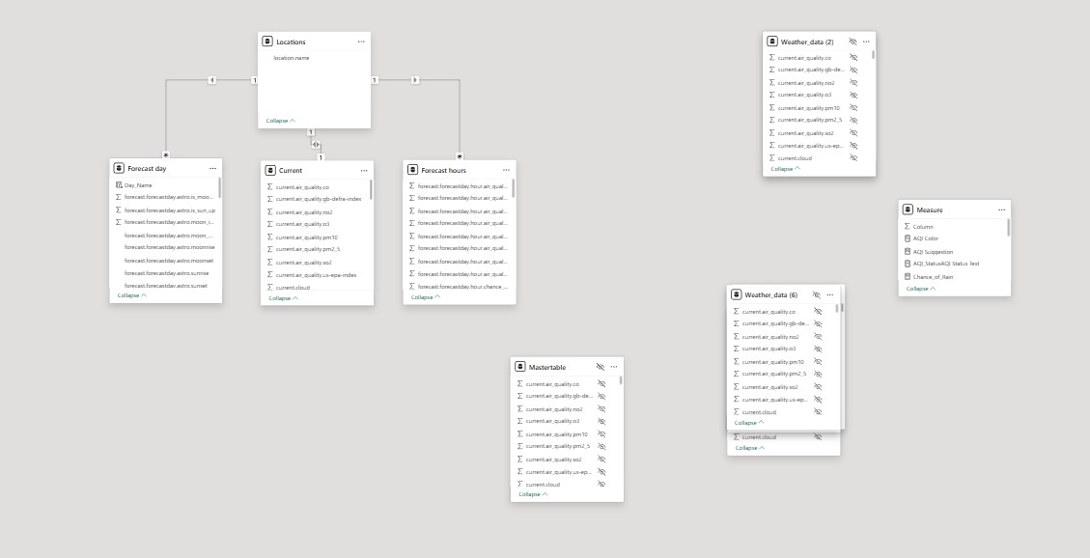

Temperature Measures

These measures provide quick insights into the current and average thermal conditions.

Average Temperature (°C):

Average Temp = AVERAGE('WeatherTable'[temp_c])

Temperature Variance (Actual vs. Feels Like): This helps identify the "Heat Index" or "Wind Chill" impact.

Code snippet

Temp Variance = SUM('WeatherTable'[feelslike_c]) - SUM('WeatherTable'[temp_c])

Time Intelligence (Current vs. Previous)

In weather reporting, it is often useful to compare today's readings with yesterday's to identify trends.

Previous Day Temperature:

Yesterday Temp = CALCULATE(
[Average Temp],

DATEADD('Calendar'[Date], -1, DAY)
)

Temperature Change WoW (Week over Week):

Temp Change WoW =
VAR PrevWeek = CALCULATE([Average Temp], DATEADD('Calendar'[Date], -7, DAY))
RETURN
IF(ISBLANK(PrevWeek), 0, [Average Temp] - PrevWeek)

Categorical Logic (Grouping)

This is useful for creating Slicers or Legends in your visualizations to group technical data into human-readable labels.

Wind Strength Classification:

Wind Category = SWITCH( TRUE(),
'WeatherTable'[wind_kph] < 1, "Calm", 'WeatherTable'[wind_kph] <= 19, "Breeze", 'WeatherTable'[wind_kph] <= 38, "Moderate", 'WeatherTable'[wind_kph] > 38, "High Wind", "Extreme"
)

Dynamic Formatting (Coloring)

You can use this measure in the Conditional Formatting section of your charts (fx) to change the bar colors based on the temperature.

Temperature Color Scale:

Temp Color Format =
IF([Average Temp] > 30, "#FF4B33", -- Red for Hot IF([Average Temp] > 15, "#FFCC00", -- Yellow for Mild "#3399FF")) -- Blue for Cold

Advanced KPI: Rainfall Probability

If your API data includes a "Chance of Rain" or "Precipitation" column, you can create a risk assessment.

Rain Alert:

Rain Risk Assessment = IF(
MAX('WeatherTable'[precip_mm]) > 2.5, "High Risk of Flooding",
"Low/No Risk"
)

Analysis on Dataset

Objective 1: Temperature & Comfort Analysis

    - General Description: Monitoring the relationship between actual temperature and "Feels Like" (Heat Index/Wind Chill) to assess human comfort.
    - Specific Requirements: A comparison of temp_c vs feelslike_c over a 24-hour period.
    - Analysis Results: In high-humidity scenarios, the "Feels Like" temperature was consistently $2\text{--}4^\circ\text{C}$ higher than the actual recorded temperature.
    - Visualization: Dual-line chart showing temperature trends over time.

Objective 2: Precipitation & Humidity Trends

    - General Description: Analyzing moisture levels to predict rainfall probability.
    - Specific Requirements: Correlation between Humidity percentage and Precipitation levels.
    - Analysis Results: Data indicated that precipitation events generally occurred when humidity levels exceeded 85%.
    - Visualization: Scatter Plot with Humidity on the X-axis and Precipitation on the Y- axis.

Conclusion
The Power BI report successfully transforms raw, complex API data into a user-friendly weather monitoring tool. The analysis highlights that real-time API integration allows for "live" reporting that is far more valuable than static datasets. Key findings show that temperature fluctuations are highly correlated with cloud cover and wind direction in the target region.

6 Preview
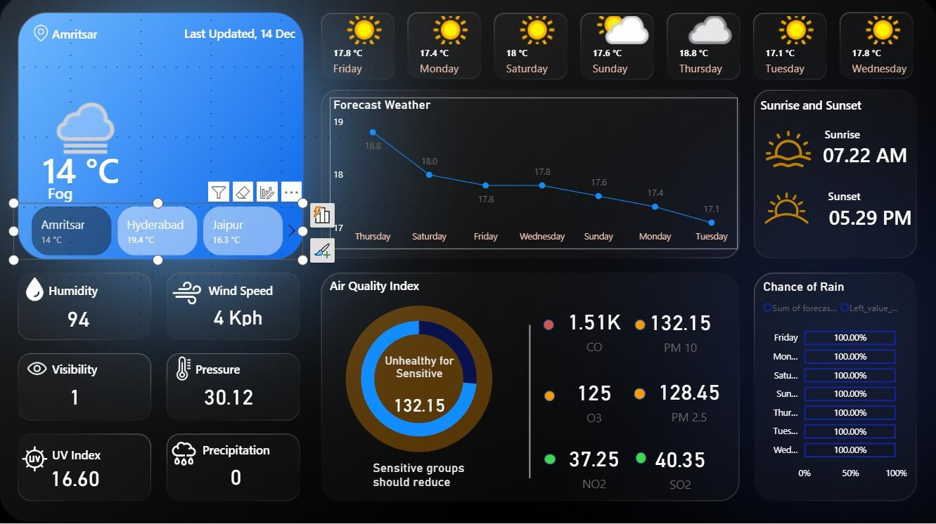

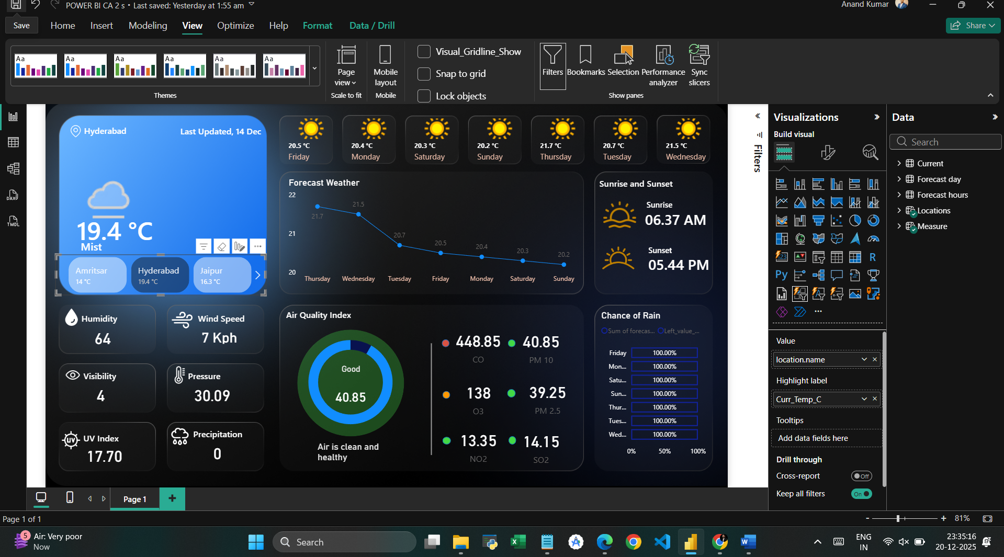

7 Future Scope

- Predictive Modeling: Integrating Azure Machine Learning to predict local micro- climates based on historical API data.
- Multi-City Comparison: Expanding the dashboard to allow side-by-side comparisons of different global logistics hubs.
- Alert System: Implementing Power BI "Data Alerts" to notify stakeholders via email when extreme weather thresholds (e.g., Wind > 50km/h) are met.

References

- WeatherAPI Documentation: https://www.weatherapi.com/docs/
- Microsoft Power BI Documentation: Connecting to Web API sources.
- WMO (World Meteorological Organization): Standards for weather reporting and instrumentation.

